AIRPORT MANAGEMENT SYSTEM:
BY:
ALEEM ABBAS 24K-3070
USMAN KHAN 24K-3032
ABDUL HADI 24K-3018

INTRODUCTION:
- Motivation:
- The motivation behind developing the Airport Management System was to design a real-world database application that simulates activities performed in an airport environment. Airports involve multiple operations such as flight management, passenger handling, airline coordination, baggage management, and staff administration. Managing all these operations manually can become inefficient and error-prone.
- This project allowed us to apply database concepts in a practical scenario by creating a centralized system that manages airport-related activities and interactions between different stakeholders such as administrators, staff members, airlines, pilots, and customers.

- Tech Stack:

Front-End
- Html/Javascript/CSS.

Back-End
- mySQL + php

- Objectives achieved:
The following objectives were successfully achieved during the development of the project:
- Developed a web-based Airport Management System capable of handling flight management and customer records.
- Designed a normalized database schema to reduce redundancy and prevent data inconsistencies.
- Implemented efficient SQL queries for managing and retrieving airport-related information.
- Added triggers to improve system interactivity and automation.
- Implemented validations to prevent duplicate flight bookings and duplicate user registrations.
- Created auditing tables to track user activities such as insertions, updates, and deletions within the system.
- Managed interactions between multiple stakeholders including customers, airport staff, and administrators

- Limitations:

Although the system performs major airport management operations, it has some limitations:
- The system depends on internet and server availability; in case of network failure or server-side errors, users may temporarily lose access to the system.
- The project does not include online payment integration or real-time aircraft tracking.
- Advanced security mechanisms and large-scale distributed database features were not implemented due to project scope limitations.
- The system is designed primarily for academic purposes and may require additional scalability and security improvements for deployment in a real airport environment.

ERD:
Logical ERD:
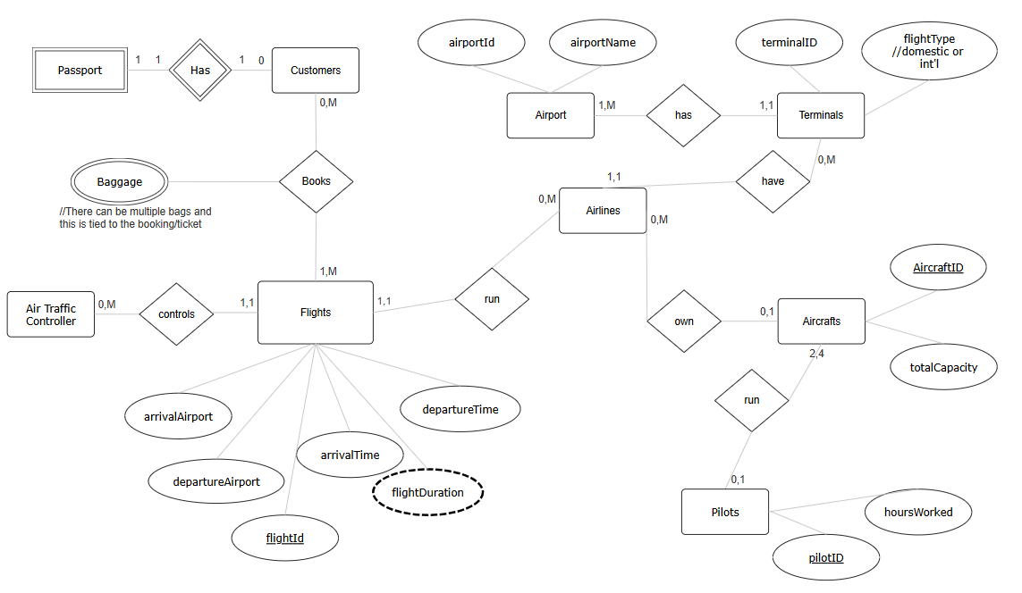
Descriptive ERD:
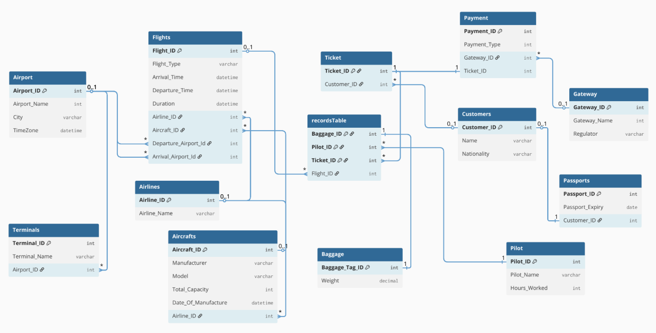

NORMALIZED SCHEMA:
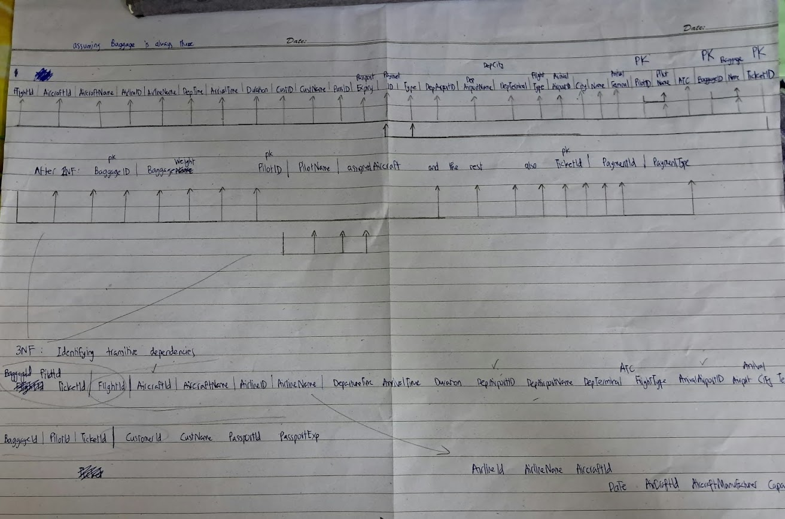

FEATURES OF THE PROJECT:
- Customers are able to register themselves along with their Passport information
- Customers can edit the added information
- Admin can view all customer records
- Customers can view available flights and book their seat.
- Customers can select a flight and book it with some baggage.
- Admin can view all flights, bookings and manages staff.

CHALLENGES:
During the development of the project, several challenges were faced:
- Designing relationships between multiple entities such as flights, customers, airlines, and baggage systems.
- Creating a normalized schema while maintaining efficient query performance.
- Implementing triggers correctly using mySQL.
- Preventing duplicate bookings and maintaining data consistency.
- Managing communication between the front-end and back-end systems.
- Handling complex SQL queries and foreign key relationships (Too many joins)
- Too much denormalization when displaying records

FUTURE WORK:

The following improvements can be added in the future:
- Integration of online ticket booking and payment gateways.
- Mobile application support for customers and staff.
- Enhanced security features such as encryption and multi-factor authentication.
- Integration with external airline reservation systems.
- Separate panel for different users: Flight managers, pilots, terminal staff.
- Customers should be able to delete past history of flights and bookings if they choose to.

